## **Name:** **Prashish Sapkota**

## **Roll No: 24071222**

## **Assignment: Internet Technologies (Wireframe)**

Task 1-

Getting started with moqups.com account setup and tools overview.

Image:

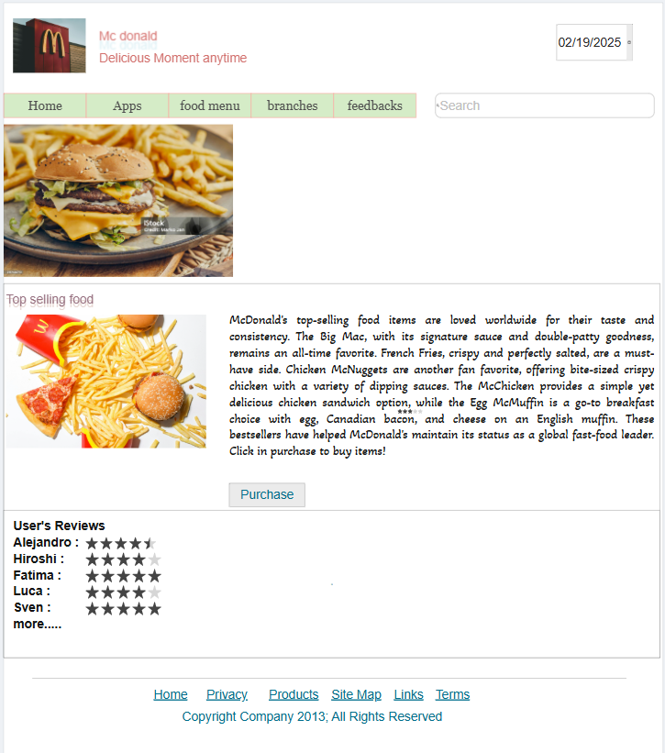

Link: <https://app.moqups.com/lW6uXSc0oE80uEcISoPG0RRrftC422fy/view/page/afa686b46>

Task-2: Design the below like wireframe structure. Use our own creativity

Image: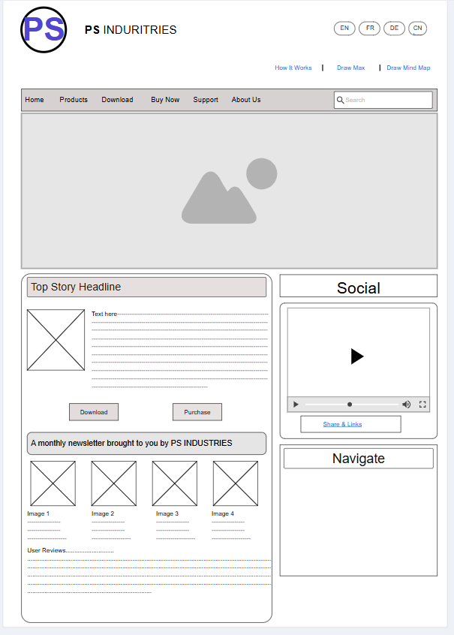Link: <https://app.moqups.com/k3X5o4hkDhFVFZ1i0gcQqRVws6c9bFc0/view/page/a8925752d>

Task 3-Create a mockup design like your college website’s contact us page. Use your own creativity for this design.

Image:

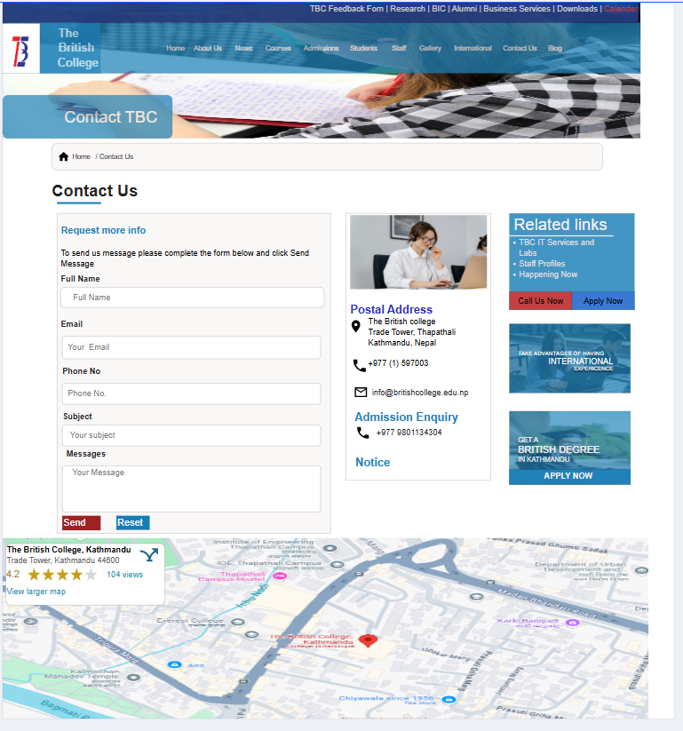

Link: <https://app.moqups.com/k3X5o4hkDhFVFZ1i0gcQqRVws6c9bFc0/view/page/ad64222d5>